Ideation Phase
Brainstorm & Idea Prioritization Template

Date | 7 July 2026
Team ID | SWTID-2026-2247
Project Name | Emotion Detection and Learning Support Engine
Maximum Marks | 4 Marks

Brainstorm & Idea Prioritization Template:
The team came together to brainstorm solutions for detecting and responding to user emotions through text. Ideas were generated around environment setup, model training, the core detection pipeline, the AI guidance engine, the Streamlit interface, and testing, then grouped and prioritized to define the project roadmap for the Emotion Detection and Learning Support Engine.
Team ID SWTID-2026-2247 used this process to move from an open problem statement to a prioritized set of epics, forming the foundation for the Emotion Detection and Learning Support Engine.
Key Outcomes of the Session:
The session produced six prioritized work areas: Environment Setup, Kaggle Model Training, the Core Detection Pipeline, the AI Guidance Engine, the Streamlit UI, and Testing & Deployment. Quick wins such as Environment Setup were separated from major, high-impact efforts such as Kaggle Model Training and the Core Detection Pipeline, giving the team a clear, prioritized roadmap to execute against.
Step-1: Team Gathering, Collaboration and Select the Problem Statement
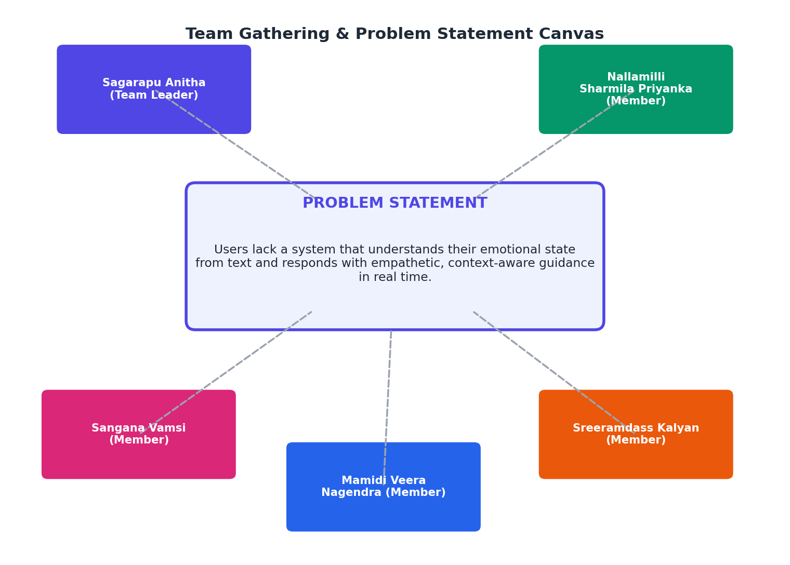

Step-2: Brainstorm, Idea Listing and Grouping
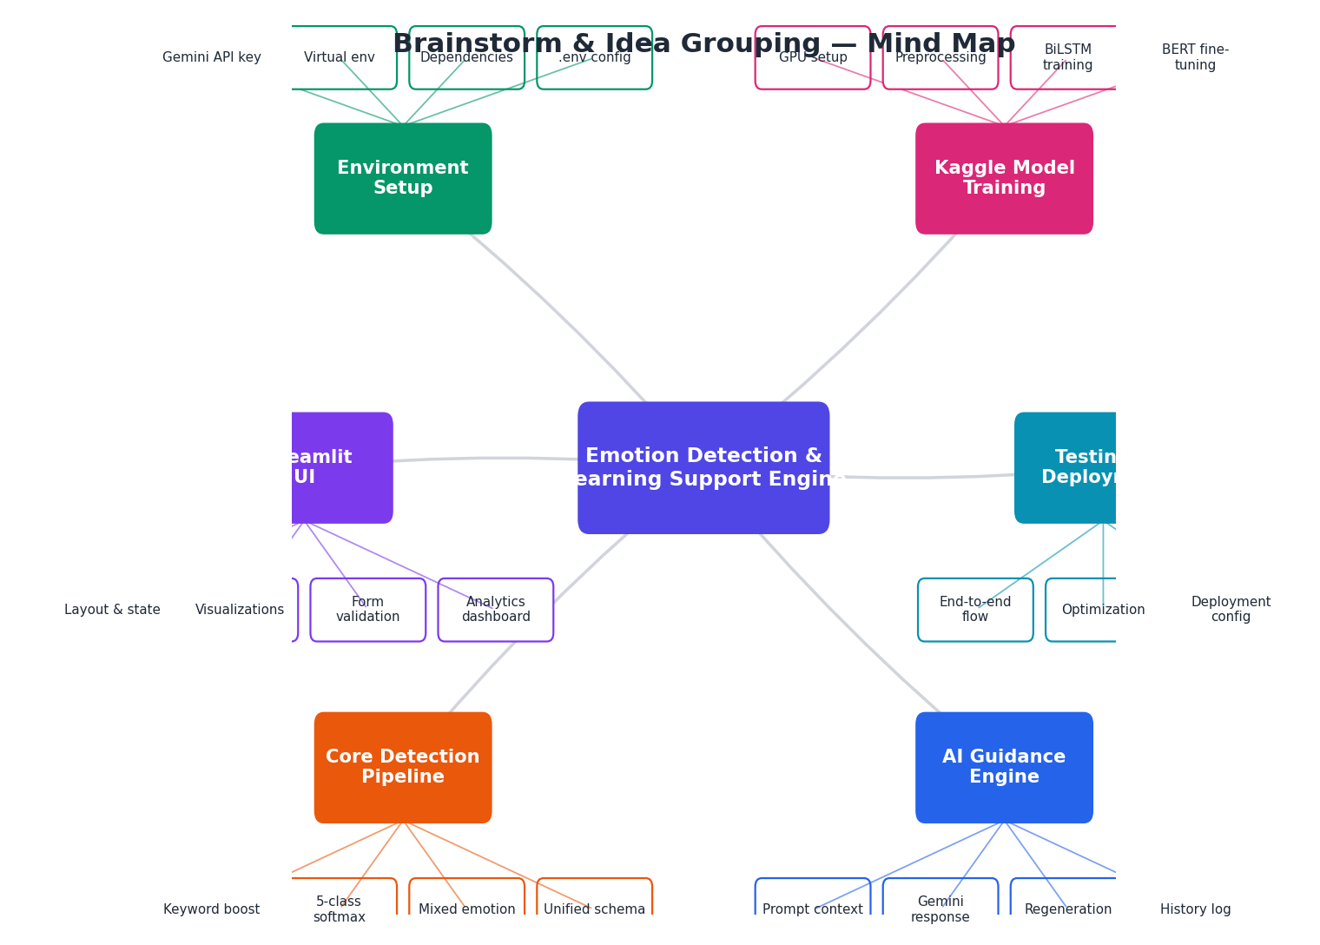

Step-3: Idea Prioritization
